**PRANAV SANDEEP RAIKAR**

**D10A43**

**UNIX LAB**

**EXPT 02 - BASIC COMMANDS**

1. ECHO: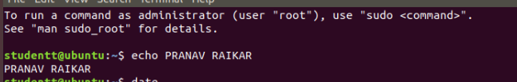

2. CLEAR:

3. EXIT:



4. DATE



5. TIME

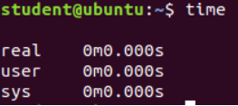

6. UPTIME



7. CAL

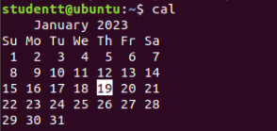

8. CAT



9. TTY



10.MAN



11. WHICH

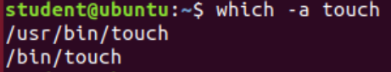

12.HISTORY

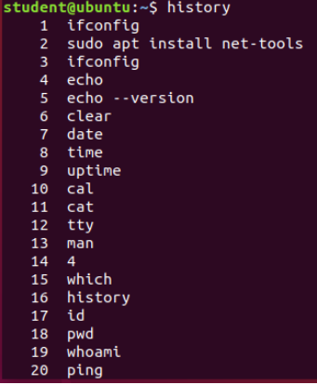

13.ID



14.PWD

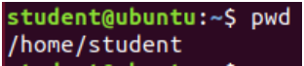

15.WHOAMI



16.PING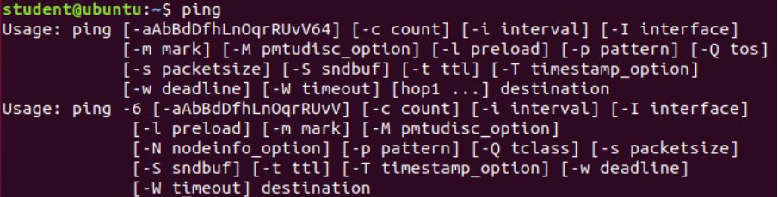

17.IFCONFIG

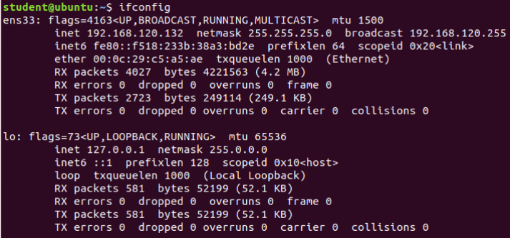

18.LPSTAT

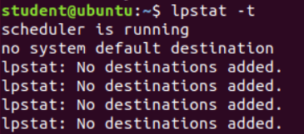

**EXPT 03 - COMMANDS FILE SYSTEM MANAGEMENT , USER MANAGEMENT**

**PRANAV SANDEEP RAIKAR**

**D10A43**

**UNIX LAB**

**Execution of File System Management Commands\**



The pwd command writes to standard output the full path name of your current directory (from the root directory).

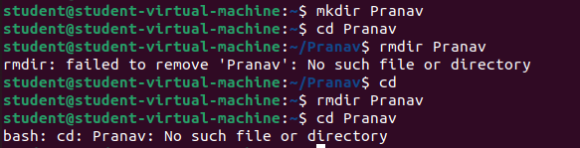

The mkdir command in Linux/Unix allows users to create or make new directories.

cd command changes from one directory to another.

mkdir removes directory

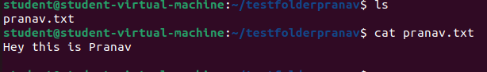

cat command opens the content present in the text file

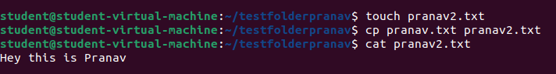

touch command creates a new file

cp command copies the content from first file mentioned to second file mentioned

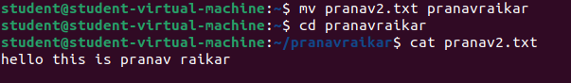

mv command is used to move one file to another file



chmod sets permissions to access the files

0 in the above command denies all permissions on the file



The wc command in UNIX is **a command line utility for printing newline, word and byte counts for files**. It can return the number of lines in a file, the number of characters in a file and the number of words in a file.



We can find the number of lines that matches the given string/pattern

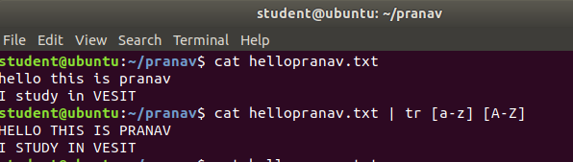

The tr command is a UNIX command-line utility for translating or deleting characters. It supports a range of transformations including uppercase to lowercase, squeezing repeating characters, deleting specific characters, and basic find and replace. It can be used with UNIX pipes to support more complex translation. tr stands for translate